DONOVAN REALTY & DEVELOPMENT
Restaurant & Hospitality Brokerage Specialists

Stew N’ Dolly’s Place
46–48 Main Street | Ogdensburg, NJ 07439
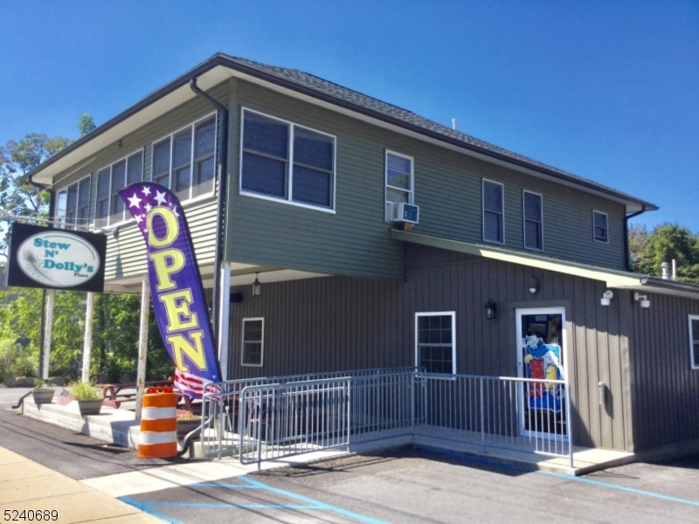
Asking Price: $895,000

Property Overview
- Building Size: 1,760 SF Main Level + 2,600 SF Basement (±4,360 SF Total)
- Lot Size: 0.60 Acres
- Seating Capacity: 49
- Parking: 20 Spaces (1 Handicapped)
- Utilities: Natural Gas | City Water | Septic

Key Highlights
- Fully Renovated in 2020 – $600,000 invested
- Liquor License Included (1916-32-004-006)
- Legal Closing Time: 2:00 AM
- ADA Accessible
- Security & Sprinkler Systems
- Gross Sales: ~$260,000
- Upstairs Income: ~$30,000
- Real Estate Taxes: ~$15,000 annually
- Insurance: ~$6,496 (Fire & Liquor)
- Hours: 1 PM – 2 AM

Disclaimer: The information contained herein has been obtained from sources deemed reliable but is not guaranteed and is subject to errors, omissions, change of price, prior sale, or withdrawal without notice. Prospective purchasers are advised to conduct their own independent due diligence. Donovan Realty & Development represents the seller exclusively unless otherwise disclosed.

